LEKTIRA BR. 4
,,PIPI DOLGIOT ^ORAP,, - ASTRID LINDGREN
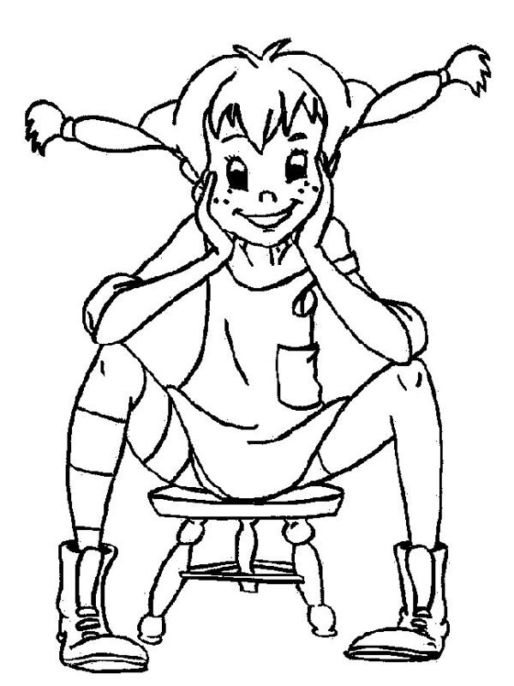

Oboj me!

Pipi Dolgiot ^orap e detski roman.

prozno delo pove}e likovi

ROMAN

podolga sodr`ina pove}e nastani

- Glavni likovi vo romanot se:
____________________________________________________________
- So koi `ivotni `ivee:_________________________________________
- So kogo `ivee Pipi vo ku}ata? _______________________________
- Opi{i kako izgleda Pipi Dolgiot ^orap:__________________________
_________________________________________________________________________________________________________________________________________________________________________________________________________

- So kakvi karakterni osobini se odlikuva Pipi? ___________________
____________________________________________________________________________________________________________________________________________________________________________________
- Kade naj~esto se slu~uvaat nastanite? ___________________________
______________________________________________________________________________________________________________________________________
- Otkako Pipi vleze vo `ivotot na Anika i Tomi, kakov stana nivniot `ivot? ______________________________________________________
________________________________________________________________________________________________________________________
- Kakvi se pove}eto postapki na Pipi? (dali se kulturni i pristojni)
______________________________________________________________________________________________________________________________________
- Nabroj nekolku nevozmo`ni raboti {to Pipi gi ,,napravila,,:
_____________________________________________________________________________________________________________________________________________________________________________________________
- Odberi nekoja interesna slu~ka od knigata i preraska`i ja na kratko ___________________________________________________________________
________________________________________________________________________________________________________________________________________________________________________________________________________________________________________________________________________________________________________________________________________________________________________________________________________________________________________________________________________________________________________________________________________________________
- [to misli{ kakva poraka sakala da prati pisatelkata so ovaa kniga? ___________________________________________________________________
_________________________________________________________________________________________________________________________________________________________________________________________________________

Ime i prezime______________________________ odd:

Датум: 30.03.2020
Одд.наставник:

